Periodic Table
(freeware)
Periodic Table views some data about the atoms. In order to view the available information just click on the atomic symbol.

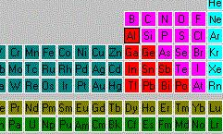

A new dialog box comes up with a variety of data.

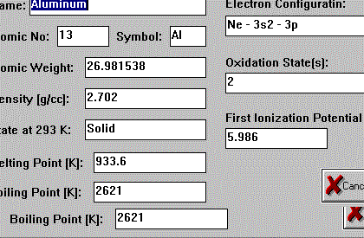

The reporting button here enables you to cut and paste the information into your document.

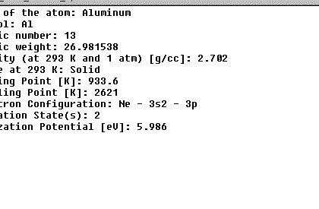

Download at: http://www.taftan.com/

